Big Mountain Resort Pricing Analysis Summary

By Xiangnan Shi

This report summarizes the process of analyzing the correlation between ski resort ticket price and common resort facilities and using the findings to guide the pricing strategy and decision making of future facility improvement.

# Ticket Price vs Resort Features

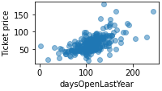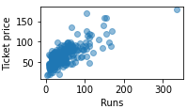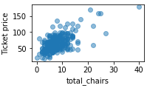An exploratory data analysis (EDA) was conducted from a high level to look into the correlation between ticket price and facility features. A clear connection was found in several features, such as total chairs, number of runs and open days as illustrated in the graphs.

As a result of the EDA, it was believed that a resort’s price can be reflected by its facility features and a model can be built accordingly to predict a reasonable price.

# Build A Pricing Model

Two types of models, Linear Regression and Random Forest, have been built and evaluated. As a result, Random Forest model performed slightly better than the other and showed lower mean absolute error. Thus, it was chosen for further analysis.

# Model Deployment and Result

The above model was deployed on all data set to predict a reasonable ticket price. The modeled price is $95.87, which is higher than current price of $81. In addition, the model evaluated a few scenarios where facility features are changed, such as closing runs, adding a chair lift, adding snow making area, etc., and predicted price change in each scenario.

# Recommendations

Based on the above analysis, several recommendations were made for Blue Mountain to consider in order to increase profit:

1. Increase the current ticket price to $96 to reflect the true market price.
2. Closing 1 run doesn’t seem to have any impact on ticket price. This can be considered to lower operating cost.
3. Increasing vertical drop seems to be very effective at raising price.
4. For future facility improvement, it’s recommended to use this model to predict what the new price is likely to be. It can then be used to compare against the cost to justify whether an improvement makes economic sense.